Project SHINE (Utica College)
Students Helping in the Naturalization of Elders
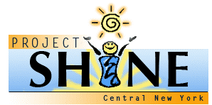
ESL & Citizenship
Reflection Log
Coach Name_______________________ Date______________________
Learner Name(s) List (Please learn the names of your learners!):
__________________________________ ________________________________
__________________________________ ________________________________

Instructions: Use this form as an aide to help you reflect upon your experiences with Project SHINE. Complete the form after each session and return it to the binder in your classroom.

Major Activities:

Observations about specific learners:

Successes/Excitements/What worked:

Issues/Challenges/Concerns/What didn’t work:

Connections to readings or to academic field:

*Contact Project SHINE on the Utica College Campus
shine@utica.edu (315) 223-2550 (Transportation Problem? Contact Student Activities (315) 792-3036

